**Ex No:02 BOOK BANK REGISTRATION SYSTEM**

**USE CASE DIAGRAM:**

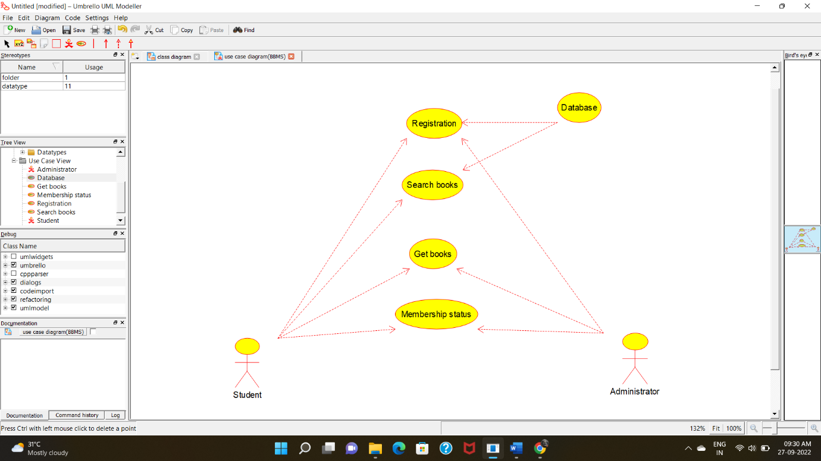

**CLASS DIAGRAM:**

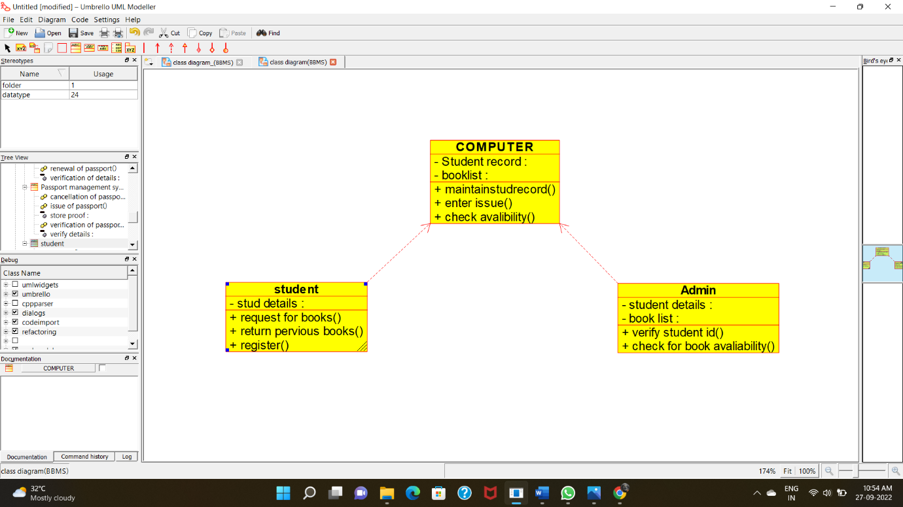

**ACTIVITY DIAGRAM:**

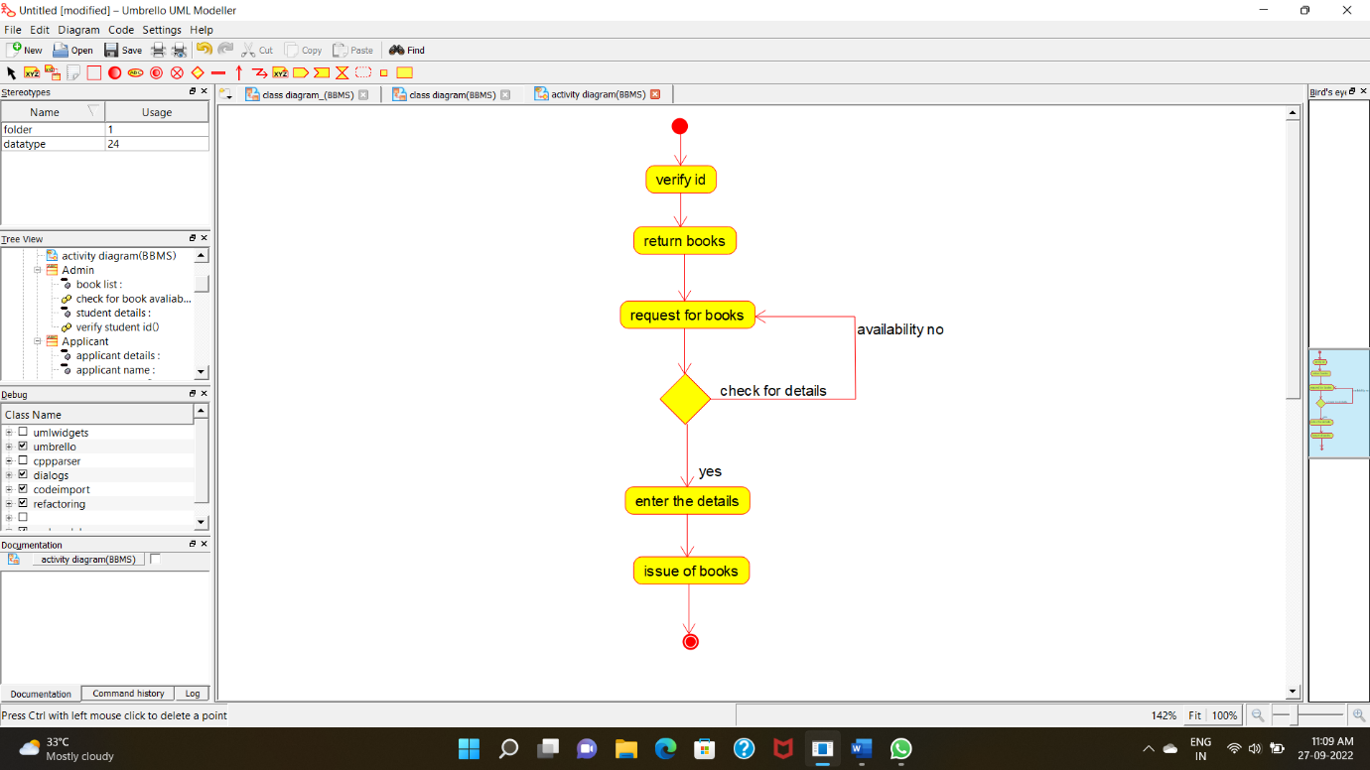

**SEQUENCE DIAGRAM:**

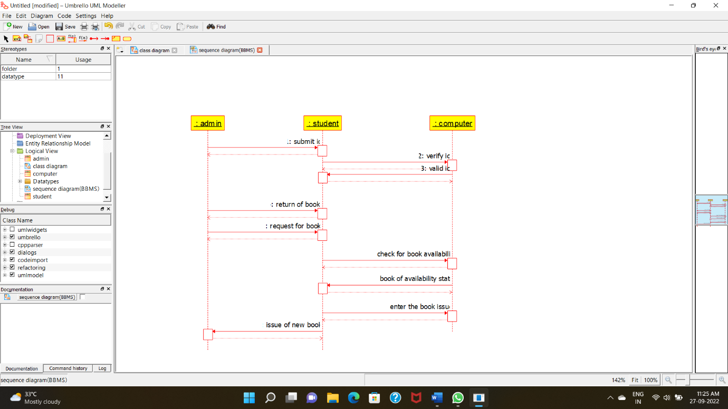

**COLLABORATION DIAGRAM:**

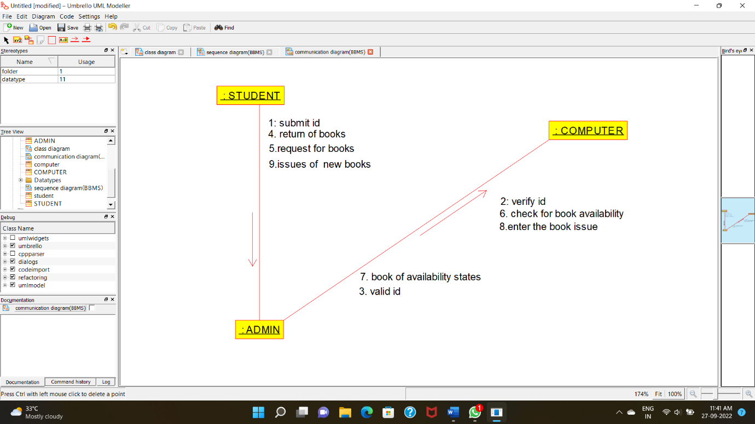

**STATE CHART DIAGRAM:**

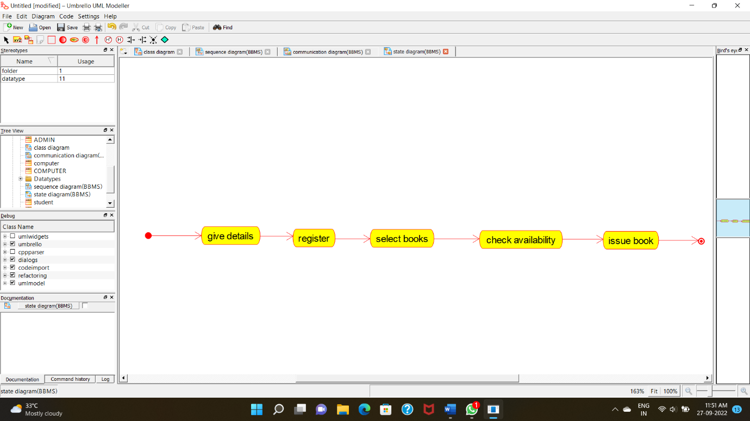

**COMPONENT DIAGRAM**

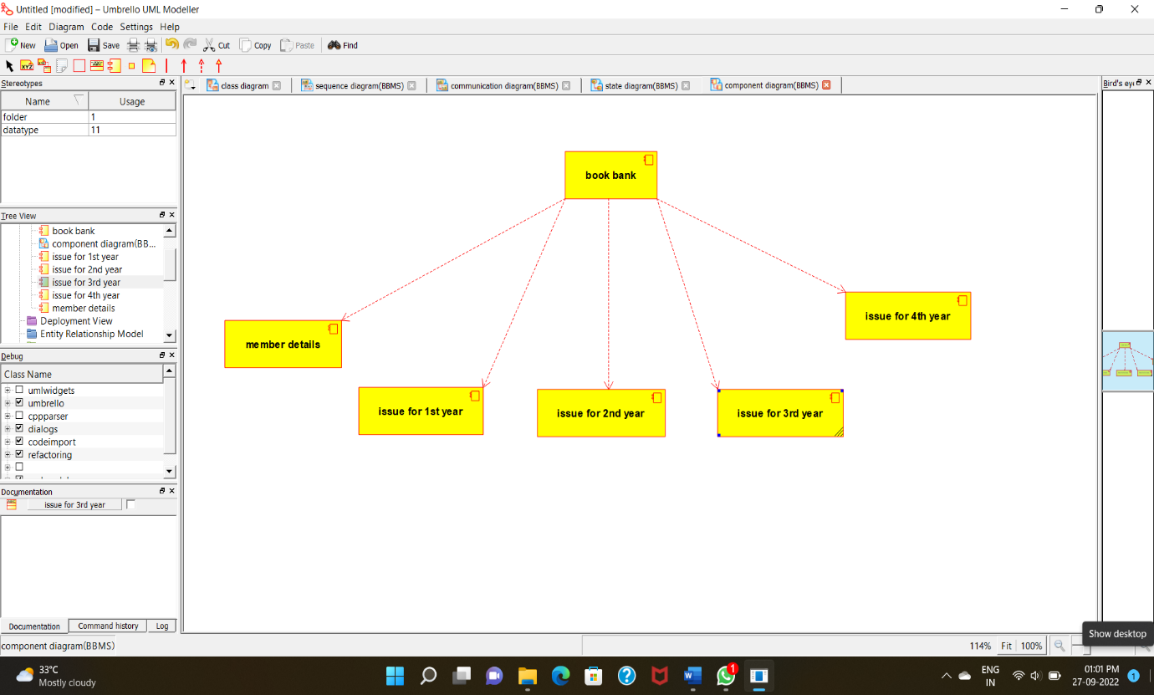

**DEPLOYMENT DIAGRAM :**

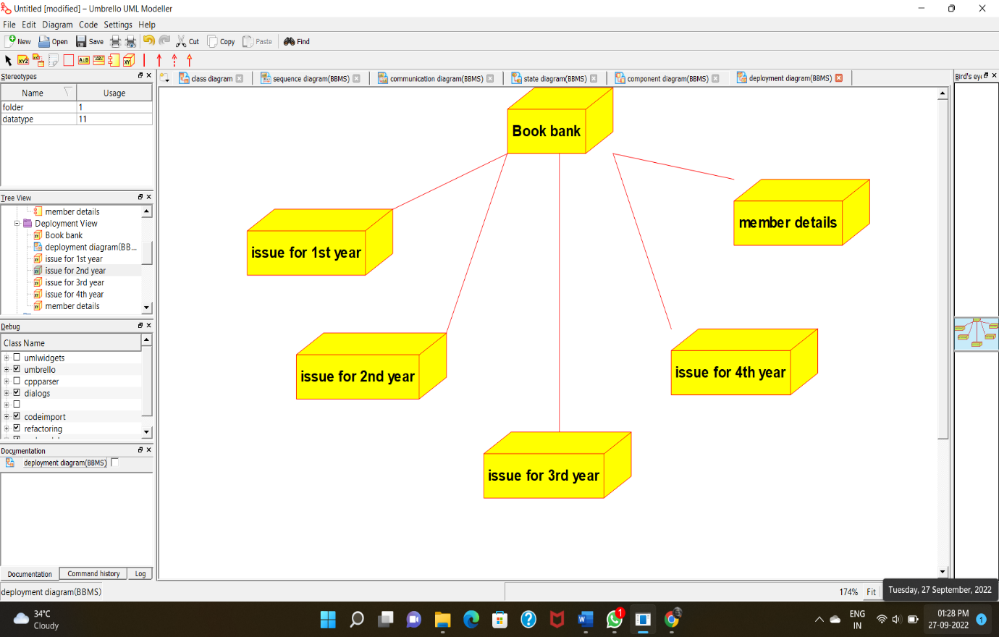

**PACKAGE DIAGRAM:**

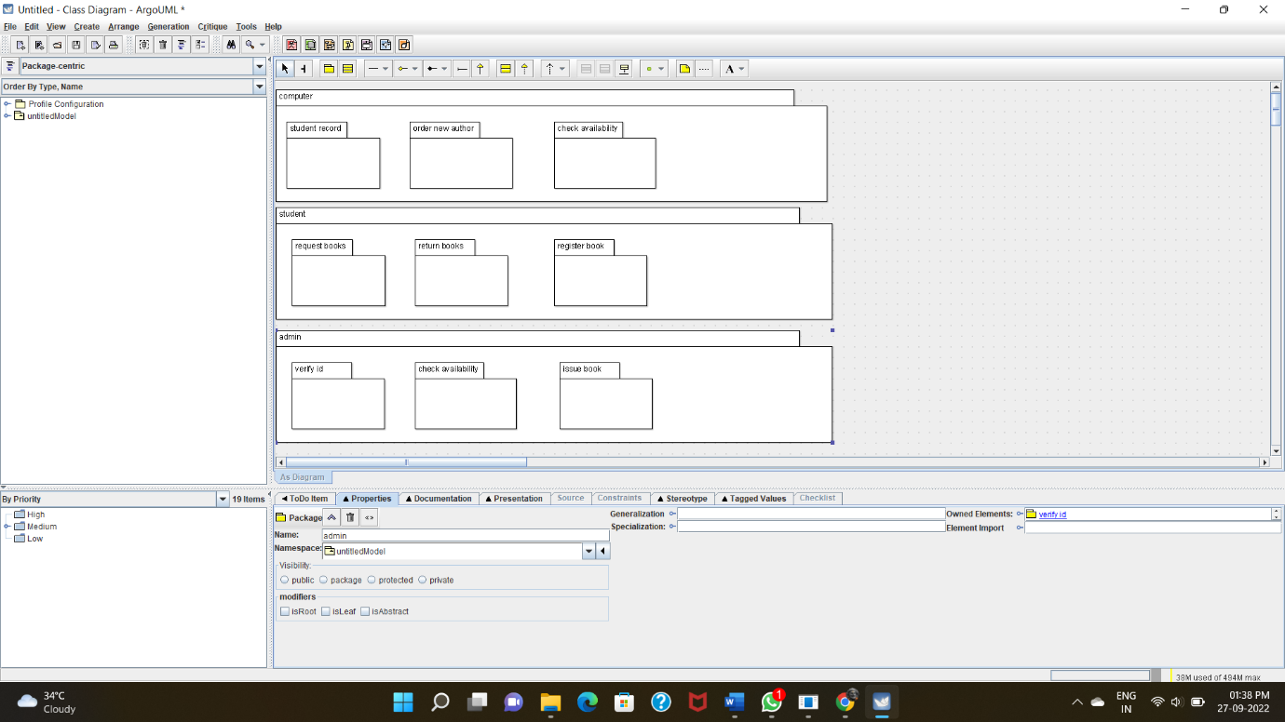

**PROGRAM CODING:**

**ADMIN:**

/**

* Class Admin

*/

public class Admin {

//

// Fields

//

private void student_details;

private void book_list;

//

// Constructors

//

public Admin () { };

//

// Methods

//

//

// Accessor methods

//

/**

* Set the value of student_details

* @param newVar the new value of student_details

*/

private void setStudent_details (void newVar) {

student_details = newVar;

}

/**

* Get the value of student_details

* @return the value of student_details

*/

private void getStudent_details () {

return student_details;

}

/**

* Set the value of book_list

* @param newVar the new value of book_list

*/

private void setBook_list (void newVar) {

book_list = newVar;

}

/**

* Get the value of book_list

* @return the value of book_list

*/

private void getBook_list () {

return book_list;

}

//

// Other methods

//

/**

*/

public void verify_student_id()

{

}

/**

*/

public void check_for_book_avaliability()

{

}

}

**STUDENT:**

/**

* Class student

*/

public class student {

//

// Fields

//

private void stud_details;

//

// Constructors

//

public student () { };

//

// Methods

//

//

// Accessor methods

//

/**

* Set the value of stud_details

* @param newVar the new value of stud_details

*/

private void setStud_details (void newVar) {

stud_details = newVar;

}

/**

* Get the value of stud_details

* @return the value of stud_details

*/

private void getStud_details () {

return stud_details;

}

//

// Other methods

//

/**

*/

public void request_for_books()

{

}

/**

*/

public void return_pervious_books()

{

}

/**

*/

public void register()

{

}

}

**COMPUTER:**

/**

* Class COMPUTER

*/

public class COMPUTER {

//

// Fields

//

private void Student_record;

private void booklist;

//

// Constructors

//

public COMPUTER () { };

//

// Methods

//

//

// Accessor methods

//

/**

* Set the value of Student_record

* @param newVar the new value of Student_record

*/

private void setStudent_record (void newVar) {

Student_record = newVar;

}

/**

* Get the value of Student_record

* @return the value of Student_record

*/

private void getStudent_record () {

return Student_record;

}

/**

* Set the value of booklist

* @param newVar the new value of booklist

*/

private void setBooklist (void newVar) {

booklist = newVar;

}

/**

* Get the value of booklist

* @return the value of booklist

*/

private void getBooklist () {

return booklist;

}

//

// Other methods

//

/**

*/

public void maintainstudrecord()

{

}

/**

*/

public void enter_issue()

{

}

/**

*/

public void check_avalibility()

{

}

}